TRƯỜNG ĐẠI HỌC BÁCH KHOA
ĐẠI HỌC QUỐC GIA TP HỒ CHÍ MINH



HOMEWORK
MẠNG MÁY TÍNH (THỰC HÀNH) – LAB 8

Giảng viên hướng dẫn: Ths. Bùi Xuân Giang

Sinh viên thực hiện: Trần Minh Tân

Mã số sinh viên: 2012018

Lớp: L10.

Thành phố Hồ Chí Minh – 2022

1. For each of the first 8 Ethernet frames, specify the source of the frame (client or server), determine the number of SSL records that are included in the frame, and list the SSL record types that are included in the frame. Draw a timing diagram between client and server, with one arrow for each SSL record. the source of the frame (client or server)
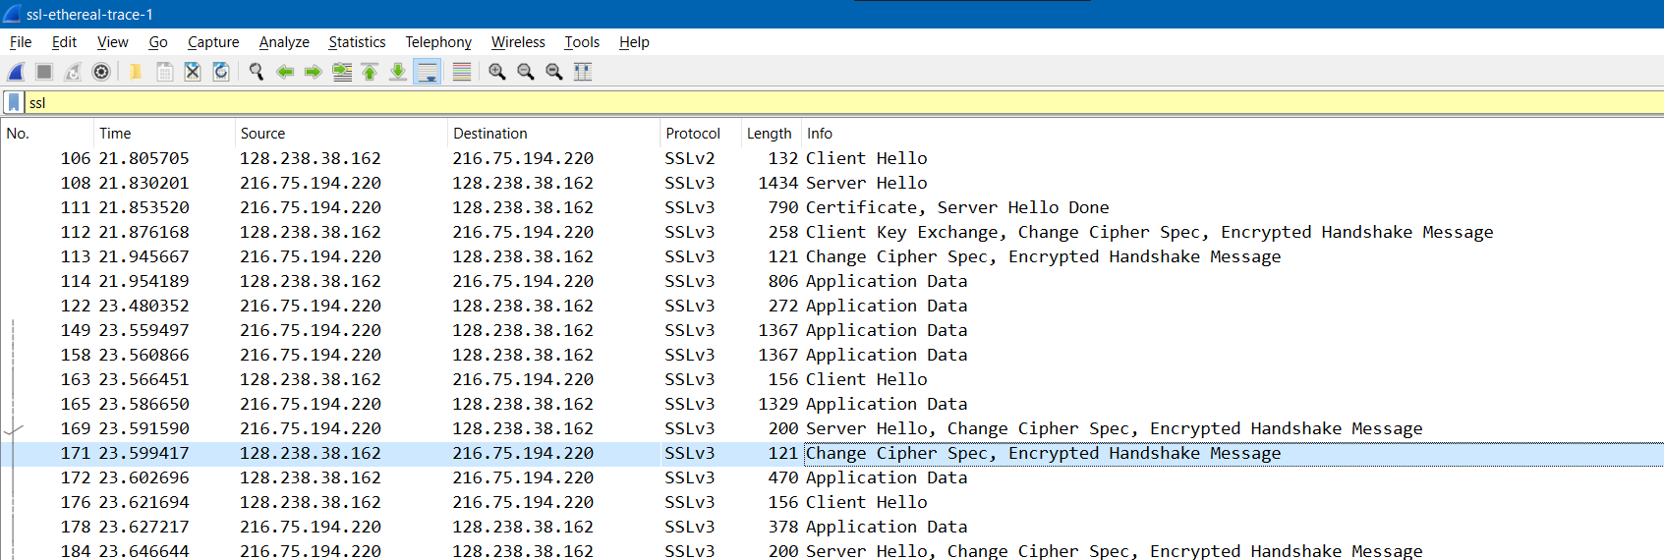
Line | Source | Destination | SSL type | SSL records
106 | 128.238.38.162 | 216.75.194.220 | Client Hello | 1
108 | 216.75.194.220 | 128.238.38.162 | Server Hello | 1
111 | 128.238.38.162 | 216.75.194.220 | Certificate, Server Hello Done | 2
112 | 128.238.38.162 | 216.75.194.220 | Client Key Exchange, Change Cipher Spec, Encrypted Handshake Message | 3
113 | 216.75.194.220 | 128.238.38.162 | Change Cipher Spec, Encrypted Handshake Message | 1
114 | 128.238.38.162 | 216.75.194.220 | Application Data | 1
122 | 216.75.194.220 | 128.238.38.162 | Application Data | 1
149 | 216.75.194.220 | 128.238.38.162 | Application Data | 1

Timing diagram:
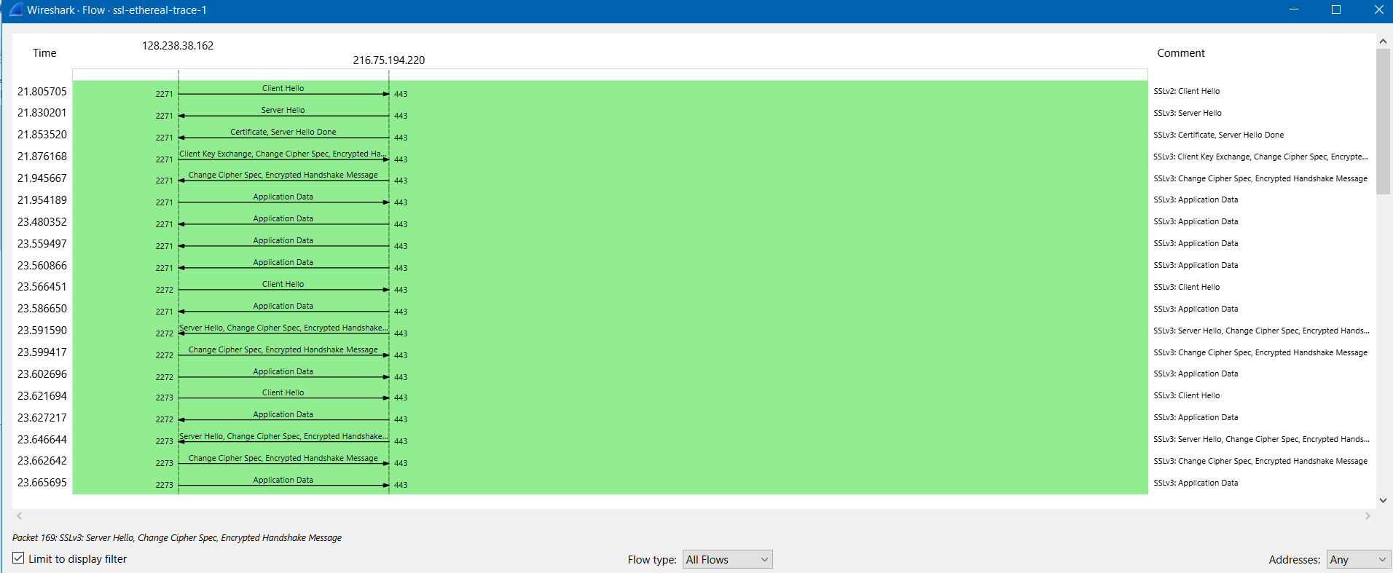
2. Each of the SSL records begins with the same three fields (with possibly different values). One of these fields is “content type” and has length of one byte. List all three fields and their lengths.
- Content type: 1 byte.
- Version: 2 bytes.
- Length: 2 bytes.
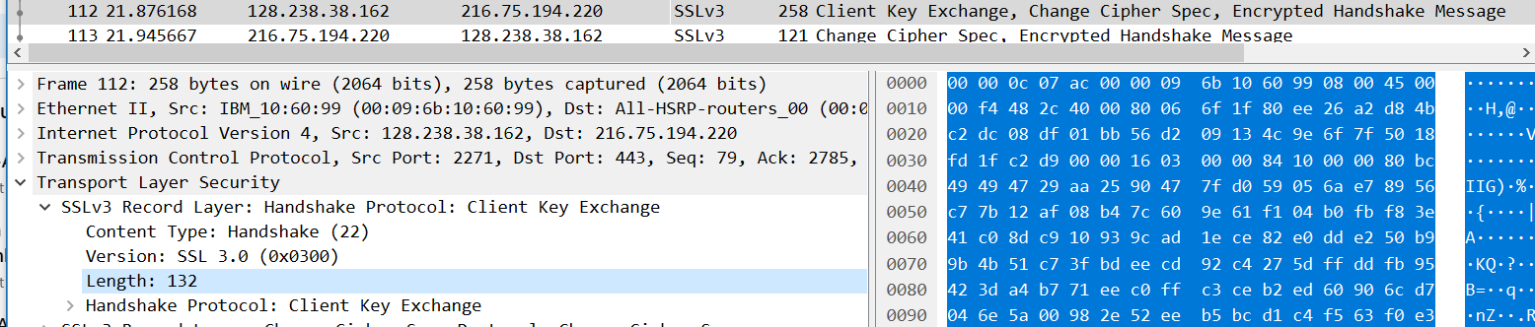
3. Expand the ClientHello record. (If your trace contains multiple ClientHello records, expand the frame that contains the first one.) What is the value of the content type?
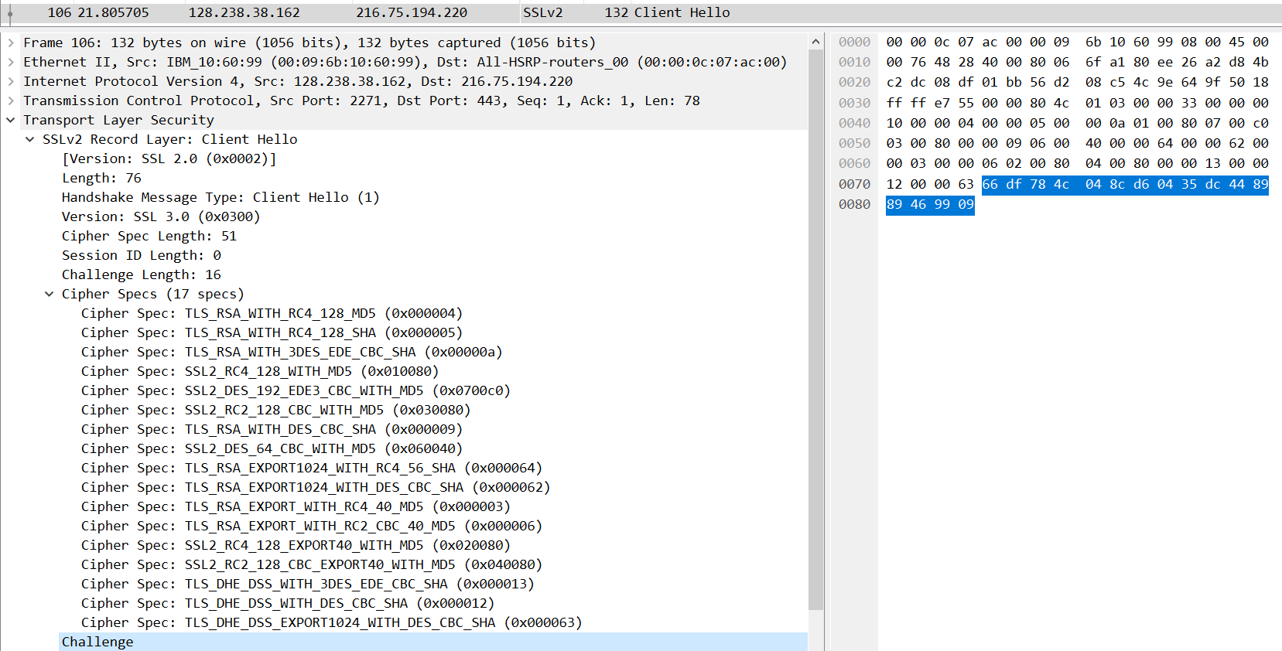
Content type value is 22
4. Does the ClientHello record contain a nonce (also known as a “challenge”)? If so, what is the value of the challenge in hexadecimal notation?
Yes it is. The value of the challenge in hexadecimal notation is 66 df 78 4c 04 8c d6 04 35 dc 44 89 89 46 99 09 .
5. Does the ClientHello record advertise the cyber suites it supports? If so, in the first listed suite, what are the public-key algorithm, the symmetric-key algorithm, and the hash algorithm?
- Public key algorithm: RSA
- Symmetric‐key algorithm: RC4
- Hash algorithm: MD5
6. Locate the ServerHello SSL record. Does this record specify a chosen cipher suite? What are the algorithms in the chosen cipher suite?
Yes, they are RSA, RC4 and MD5. 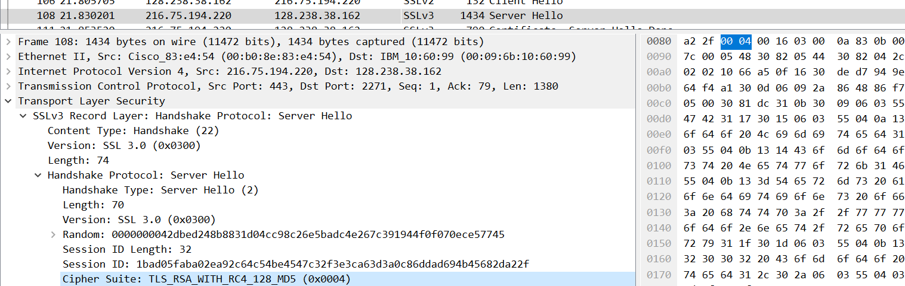
7. Does this record include a nonce? If so, how long is it? What is the purpose of the client and server nonces in SSL?
Yes, the length of this nonce is 32 bits long (28bits data + 4 bits time). The purpose of the client and server nonces in SSL is used for attack preventing.
8. Does this record include a session ID? What is the purpose of the session ID?
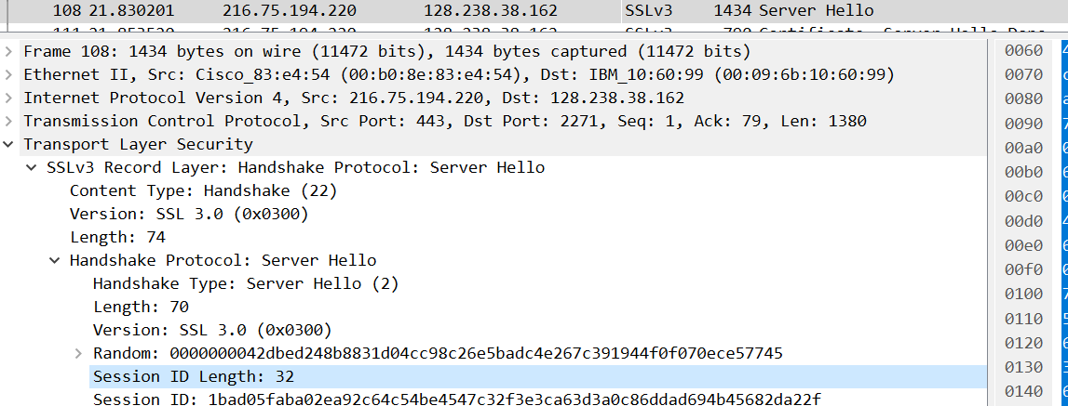
Yes, the purpose of the session ID is help the client to resume the session later by using this session ID.
9. Does this record contain a certificate, or is the certificate included in a separate record. Does the certificate fit into a single Ethernet frame?
No, there is no certificate in this record. The certificate is in the separate record. Yes, the
certificate fit into a single Ethernet frame.
10. Locate the client key exchange record. Does this record contain a pre-master secret? What is this secret used for? Is the secret encrypted? If so, how? How long is the encrypted secret?
Yes, it contains a pre-master secret. This secret is used for creating the master secret. The secret is encrypted by public key, whose length is 120 bytes.
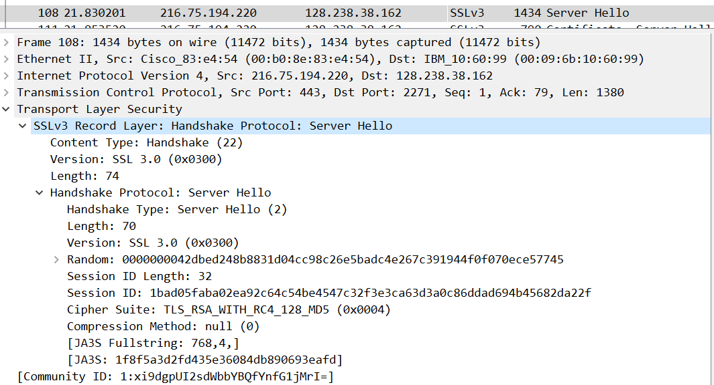
11. What is the purpose of the Change Cipher Spec record? How many bytes is the record in your trace?
The Change Cipher Spec record is used to indicate the content of the next SSL records will be encrypted. The length of the record in my trace is 6 bytes.
12. In the encrypted handshake record, what is being encrypted? How?
All handshake messages and MAC addresses are concatenated and encrypted. They are sent to the server.
13. Does the server also send a change cipher record and an encrypted handshake record to the client? How are those records different from those sent by the client?
Yes, the server’s encrypted handshake contains all the handshake messages sent from the server. Other contains messages sent from client.
14. How is the application data being encrypted? Do the records containing application data include a MAC? Does Wireshark distinguish between the encrypted application data and the MAC?
The symmetric encryption algorithm is used to encrypt the application data. Yes, the records containing application data include a MAC. No, Wireshark did not distinguish between the encrypted application data and the MAC.
15. Comment on and explain anything else that you found interesting in the trace.
I don’t have any comments here.

